Homework 10th October 2019 Blue Class Year 4 to do before Wednesday

English:

We have been looking at writing sentences with conjunctions, and have investigated using a conjunction at the beginning of sentences rather than to join two clauses together.

<https://www.bbc.co.uk/bitesize/topics/zwwp8mn/articles/zqk37p3> explains more about conjunctions.

[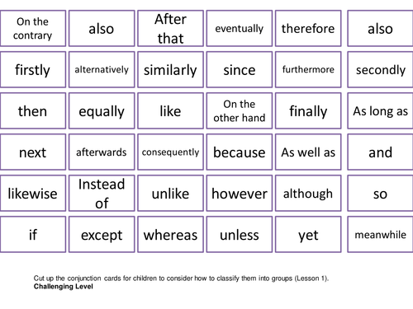](https://www.google.co.uk/url?sa=i&rct=j&q=&esrc=s&source=images&cd=&ved=2ahUKEwikga_rkZDlAhWpxYUKHZdgDTwQjRx6BAgBEAQ&url=https://www.tes.com/teaching-resource/conjunctions-ks2-5-lessons-and-activites-football-euros-themed-spag-11297674&psig=AOvVaw2hW448OcT98M9DiXilRZt7&ust=1570743545680538)

Use at least 5 of these or other conjunctions to write a paragraph about your hobbies or home life (without relying on ‘and’)

Extension: Write a short story about when the elephants came out of the walls.

Maths:

This week we have embarked on adding 4 digit numbers without relying on column (vertical) addition. Have a go at solving these calculations using other methods eg. Place value grids, Base 10 drawings as well as column method. 

Topic: What was special about Roman Baths? Find or draw 3 interesting facts ready for our next lesson.

Please keep reading and writing in your reading journal. I will be taking all the reading records in on Tuesday to see how many times your child is reading. If your child keeps forgetting to bring their book home, please alert me and I will give them even more reminders.