Home log-in

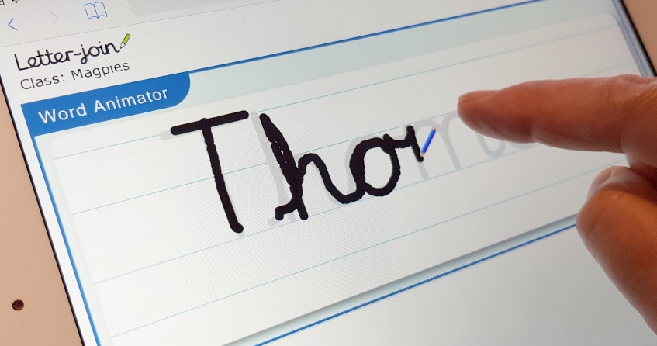
Dear Parents,
Our school is now part of the Letter-join handwriting scheme and our pupils can log in to the Letter-join website on iPads and tablets as well as desktop and laptop computers at home.
There you will find the same, easy-to-use handwriting resources that we use at school.

LOG-IN
Log in at www.letterjoin.co.uk and then use the log-in option with these details:
User name: Barrington_2
Password: class2
PC Browsers:
Letter-join will work on the following browsers on PCs/Macs:
• Google Chrome
• Firefox
• Safari
Do not use Internet Explorer
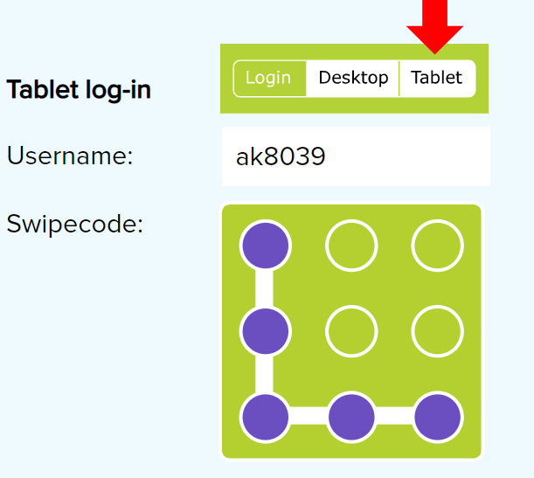
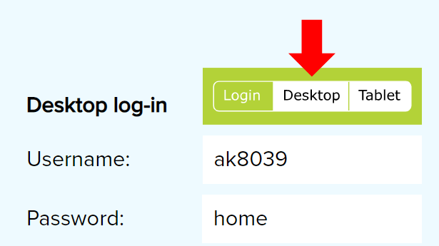

Try some fun activities;
- Click on fun on the LHS.
- This will give you another list, click on magic
- Now choose one of your tricky words and choose and background.

