Minibeast enquiry survey
Look carefully in your microhabitat and count up the number of minibeasts you have found.
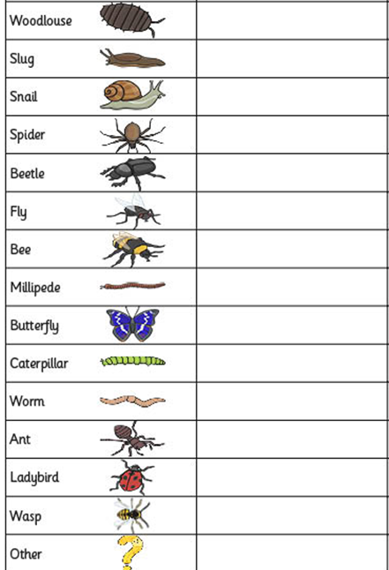
Minibeast Number found

