It was a very special day at Barrington Primary School when a very important man came to visit.
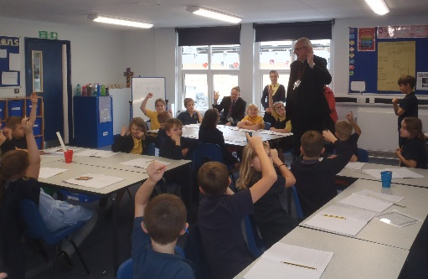
The Bishop of Ely in Blue class, asking questions
Barrington School has had a new extension costing £3 million which had transformed the school. It now has a much larger playground, a lovely library filled with bean bags and cubby holes to sit and read a wide range of books. There are new toilets for staff and children, a lift and 4 very high tech classrooms, an ICT suite and a well-being room.
On Wednesday 16th September, the Bishop of Ely came to Barrington. He was given a guided tour of the whole school by the School Ambassadors, Molly and Jim, accompanied by Rev. Felicity from All Saints Church in Barrington.
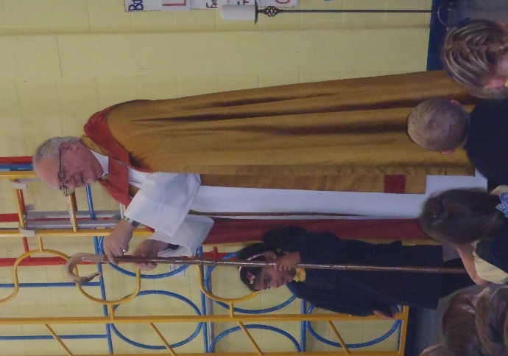
Bishop Steven in his robes, talking to the whole school in assembly time
Mrs Davies, the headteacher of the sparkling school explained how the £3 million project had come about. “Now the cement works chimney has been demolished, 220 houses are planned for the site. We need to provide a school for the children living in the houses.”
She is obviously thrilled will the building project at the school. “The Ministry of Design helped to plan the library which is now such a welcoming place to read and explore books. The staff toilets are particularly pleasing as they are pink!”
Bishop Steven and his team stayed for the afternoon and he led Collective worship for the school, answering questions about what it is like to be a Bishop as well as showing the children his formal robes.
When asked about the new building and rooms he said, “I think your new school is light and a lovely big space. I hope you will all be people who shine with friendship, courage and forgiveness.”
The teachers, parents and children at Barrington Primary School are all thrilled with the success of the new building and are looking forward to learning in the lovely spacious classrooms.
Journalist: Mrs McGregor and Blue Class

