All Things Bright and Beautiful
Class 2 homework choices for Summer 2019
Create a map of the town where the characters of one of the traditional stories we have read in class live (Jack, Red riding hood, Goldilocks, Gingerbread man etc) | Imagine you are Mummy bear and write instructions for making the porridge for the bear family. Remember to use time connectives! | Bake a gingerbread man including pictures and instructions on how you made it. Remember to use time connectives! | Write your own descriptive version of a Traditional tale. Which one will you choose? Will you keep to the story or change part of it?
Grow a bean plant from seed and measure its growth for 4-6 weeks and present your results with pictures and measurements (you will need to allow time for the seed to germinate!) | Find out about an animal that Charles Darwin discovered. Don’t forget to include a picture with labels and an explanation. | Write a day in the life of the Giant in ‘Jack and the Beanstalk’. What might you do? Who might be there with you? | Design a route for Little Red Riding Hood to follow so she can get to her grandmother’s house.  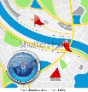
Find pictures/information of Barrington; can you find a picture of a new and old building and compare them explaining how they are different and also what is the same? | Create a wanted poster of one of the bad characters in the stories we have read in class. Remember to use lots of description! | Use different food to create a healthy, nutritional snack. | Research and find out about who Charles Darwin was. Include a drawing about his work and include at least 4 facts.
Create your own traditional style tale. Who would your hero be and what would the baddie be like? Remember to have a problem in your tale. | Listen to a piece of music inspired by an animal (eg. a movement from the Carnival of the Animals, Flight of the Bumble Bee, The Lark Ascending). Draw pictures of what the animal is doing at different points in the music and label them explaining what the music makes you think of -the clues will be in the melody, volume and speed of the music. | Write and illustrate a poem about what you find bright and beautiful.  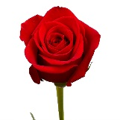  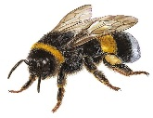 | Paint a picture of a sunflower or use plant seeds to create a summer collage picture.  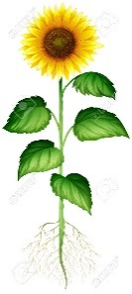
Choose at least 1 by half term and 3 by the end of term

