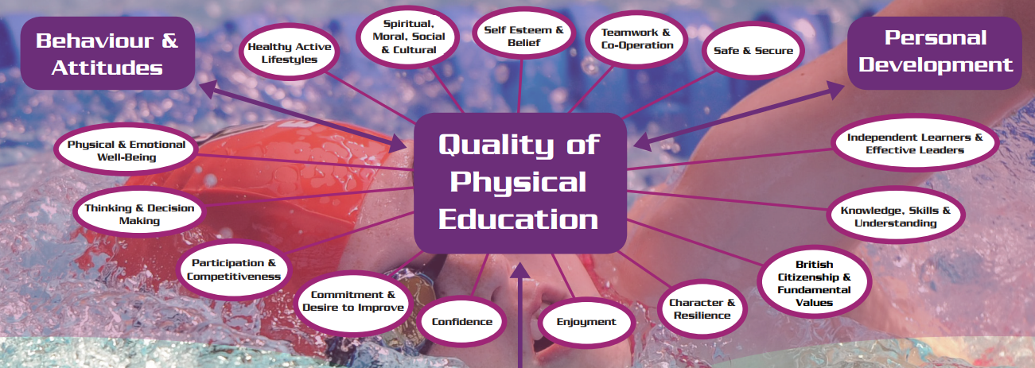
Dear all,
Whilst we understand this is an extremely difficult time for us all with covid-19 hitting the UK and leading to school closures, we at JH School of sport would like to do what we can to help and support you and your child.
We understand the importance of your child being active during this time and understand it may be more difficult if we are to self-isolate and stay in our homes, so hopefully with our knowledge and expertise you will benefit from what we are about to give you.
As we try to carry on as much as normal, I am going to give you the information necessary targeted at your child and their age group in conjunction with what would be happening within PE at school and the PE curriculum.
We know that the majority of any sporting activities will not be taking place during this time; this tells us the importance of finding ways to keep your children active when we can.

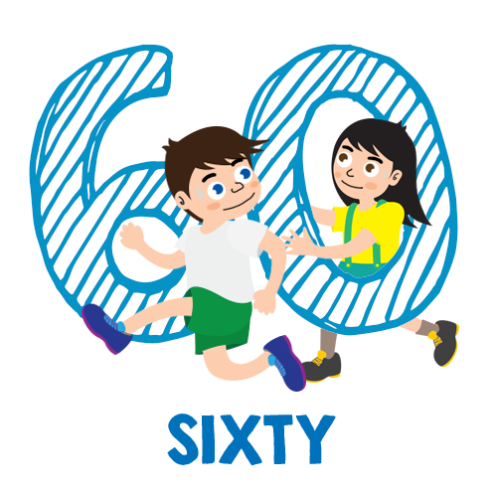
Personal challenges
While we understand some of our limitations to space and equipment, we have created up to 6 personal challenges, specific for each class, trying to make them as entertaining as possible, with variety and making sure it is beneficial for your child. We would recommend the children complete the challenges each day, as well as some of the activities we have added for each class. We hope that your child will show progression in completing these challenges and showing an improved score from taking part in the activities we give you.
Our challenges will focus on the necessary development of the child. Whilst we know that what we send you is all structured for the child, we also can’t stress enough the importance for our children to explore, create, imagine and find their own ways of being active within the day, something that we like to call free play!
Our challenges will take up anything between 30-60 minutes a day. These challenges are created to perform at once or can be spread out through the day. Fill in the challenge table to be able to see your own improvements. The page per class indicates how each challenge can be set out. Most activities can be carried out using all types of equipment from balls to apples. Many activities ask for a measurement in distance, these can be carried out anyway you choose for e.g. Metres, yards, and steps.
We have done our best to make all the challenges accessible to everyone, especially if we were to be isolated in our homes and adaptable for every child’s needs. I hope it is fairly simple to understand with a nice variety, so the children will be engaged in all the activities.
We hope the children enjoy these tasks and see an improvement as the days go by. Please feel free to change them accordingly or please don’t hesitate to contact me for some new ideas or anything questions. Any feedback would be greatly received.
It would be great to see some of their challenges as well.
Stay healthy!!!
Mr Johnny Herd
PE co-ordinator
jherd@barrington.cambs.sch.uk
jhschoolofsport@outlook.com
Every child should get at
least 60 minutes every
day of physical activity.
Red class - EYFS
Red Class have been working extremely hard on their fundamental skills with Mr Herd from developing their basic movement skills to ball motor skills with a real focus on their agility, balance, co-ordination and speed to help develop the child. They are due to do a ‘striking’ unit for the summer term.
Parent & child activity:
- Treasure chest – Place a number of objects in the centre (treasure chest). Child Vs Opponent. Clear the treasure chest one by one. Who has the most objects in their treasure chest?
X O X
- Striking a ball from a server, self-serve or from a rebound. This could be using their hand/foot/bat/racket.
Challenge:
#1 – hopping for 30 seconds on left leg followed by their right leg. A point for every time there standing foot hits the floor with the other foot elevated.
#2 – Passing and receiving a ball or object for 5 minutes with family or friend. More able to use a smaller ball or object. How many successful catches in a row can be made by the child?
#3 – Place a starter cone/object with 4 others 5 steps in front of each.
X X 5 steps X 5 steps X 5 steps X
Cone 1 2 3 4 5
Child runs to cone 2 picks it up and places it on cone 1, then runs to cone 3 picks it up and puts it on cone 1 and continues to cone 5. How long does it take the child to complete?
#4 – Throwing a ball or object in to a bucket, hoop or target. How many points can they accumulate in 3 minutes?
#5 – Shuttles racing between two markers. Relevant to space from 10 yards to 20 yards.
Challenge | #1 How many hops on each leg in 30 seconds  L R | #2 Passing & receiving a ball/object for 5 minutes (Throwing & catching) | #3 Cone/object chase (How long to complete) | #4 Target throws (How many in 3 minutes) | #5 Shuttle racing  (How far can you go in 1 minute x 2)  1 2
Monday
Tuesday
Wednesday
Thursday
Friday
Challenges | #1 How many hops on each leg in 45 seconds  L R | #2 Passing & receiving a ball/object for 5 minutes (Throwing & catching over varied distances using over arm, under arm, chest throw) | #3 Cone/object chase (How long to complete) | #4 Target throws (How many in 3 minutes) | #5 Shuttle racing  (How far can you go in 1 minute x 2)  1 2
Monday
Tuesday
Wednesday
Thursday
Friday
Orange class – Year 1 (including Red class Year 1’s) & 2
Orange Class have also been working hard on their fundamental skills with a bigger focus on their agility, balance, Co-ordination and speed (ABCS) they are due to do a ‘striking’ unit for the summer term.
Parent & child activity:
- Treasure chest – Place a number of objects in the centre (treasure chest). Child Vs Opponent. Clear the treasure chest one by one. Who has the most objects in their treasure chest?
X O X
- Striking a ball from a server or against a target. This could be using their hand/foot/bat/racket. Introduce a way of making runs after striking the ball between markers.
Challenge:
#1 – hopping for 45 seconds on left leg followed by their right leg. A point for every time there standing foot hits the floor with the other foot elevated.
#2 – Passing and receiving a ball or object for 5 minutes with family or friend. More able to use a smaller ball or object. Vary the distance and type of throw (under arm, over arm, chest throw, bounce throw) How many successful catches in a row can be made by the child?
#3 – Place a starter cone/object with 4 others 5 steps in front of each.
X X X X X
Cone 1 2 3 4 5
Child runs to cone 2 picks it up and places it on cone 1, then runs to cone 3 picks it up and puts it on cone 1 and continues to cone 5. How long does it take the child to complete?
#4 – Throwing a ball or object in to a bucket, hoop or target. How many points can they accumulate in 3 minutes?
#5 – Shuttles racing between two markers. Relevant to space from 10 yards to 20 yards.
Blue class
Blue Class have been working on a dance a unit whilst working towards creating and performing a dance, either on your own, with a partner or in a small group, on the ideas of ‘machines’. Making sure they use changes in speed, strength, level, direction and space in in their dance. They are due to do an ‘Athletics challenges’ unit for the summer term.
Challenge:
#1 – Measure a standing long jump from a starting point and write down the distance jumped using measurements you can carry out easily.
#2 – Long distance running. Preferably an outdoor run or laps of the garden over a time period of 15-20 minutes.
#3 – Throw the distance depending on space available. Find a ball or object to throw over arm as far as you can and measure and write down the distance.
#4 – Mark out a running start point to an end point between 10-20 yards apart depending on space available. How many times can you go from marker to marker in 1 minute?
#5 – Same as challenge #1 but these times with a 5 step run up.
#6 – From marker to marker – How long does it take you to complete 10 sprints? 10-20 yards apart depending on space available.
Extra activities – For Blue/Violet class see mini boot camp at the bottom. Year 5 & 6 are able to up the repetitions from 10-15 on each activity. Please see below for a boot camp template and images of each activity.

Challenges | #1 Standing long jump | #2 long distance run (15-20mins) | #3 Throw the distance | #4 Shuttle runs (1 minute) | #5 Run and jump | #6 10 Sprints
Monday
Tuesday
Wednesday
Thursday
Friday
Violet class
Violet Class have been working on their skills within hockey and putting it into some small sided competitive games. The main focus has been their dribbling and passing techniques whilst aiming to keep possession of the ball within a team. They are due to an ‘Athletics’ unit for the summer term.
Challenge:
#1 – Measure a standing long jump from a starting point and write down the distance jumped using measurements you can carry out easily.
#2 – Long distance running. Preferably an outdoor run or laps of the garden over a time period of 20-25 minutes.
#3 – Throw the distance depending on space available. Find a ball or object to throw over arm as far as you can and measure and write down the distance.
#4 – Mark out a running start point to an end point between 10-20 yards apart depending on space available. How many times can you go from marker to marker in 2 minutes?
#5 – Triple jump is a hop, skip, jump action.
#6 – From marker to marker – How long does it take you to complete 10 sprints? 10-20 yards apart depending on space available.
Extra activities – For Blue/Violet class see mini boot camp at the bottom. Year 5 & 6 are able to up the repetitions from 10-15 on each activity. Please see below for a boot camp template and images of each activity.
Challenges | #1 Standing long jump | #2 Long distance run (20-25mins) | #3 Throw the distance | #4 Shuttle runs (2 mins) | #5 Triple jump | #6 10 Sprints
Monday
Tuesday
Wednesday
Thursday
Friday

Extra Activities for Blue/Violet class
- Create your own Mini boot camp - 10 x each activity (Can all be carried out in the comfort of your own home)
Please see below a template to create your own and images of each activity.
Upper strength Core stability Lower strength
Burpees Crunches Squats
Press ups Cycles Lunges
Shadow box Plank Wall sit (30s-1m)
Bear crawls Side plank Step ups
Tricep dips Superman’s Jump squats

Place the chosen exercises in the table below and the repetitions between x10-x15
(See below for images of the exercises)
3 rounds | Upper | Core | Lower
Activity 1 x How many | ……………………………x…. | ……………………………x…. | ……………………………x….
Activity 2 x How many | ……………………………x…. | ……………………………x…. | ……………………………x….
Activity 3 x How many | ……………………………x…. | ……………………………x…. | ……………………………x….

Upper strength
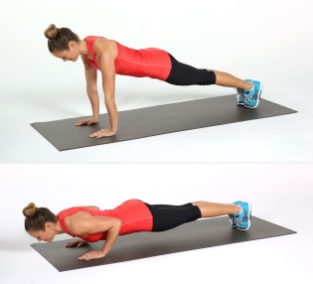
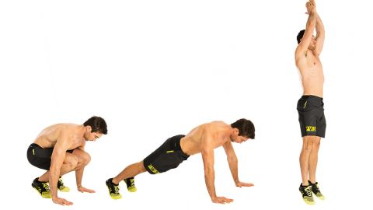
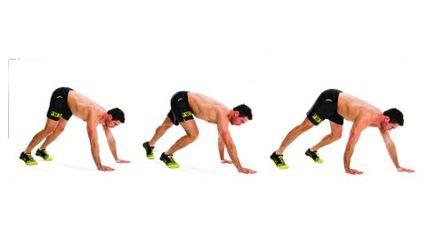
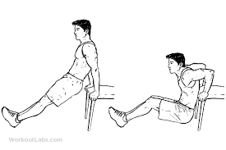
Press up Burpees Shadow boxing Bear crawls Tricep dips
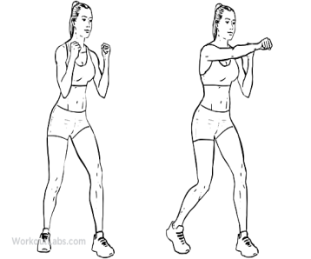

Core strength
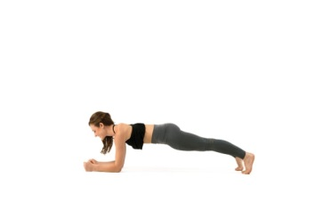
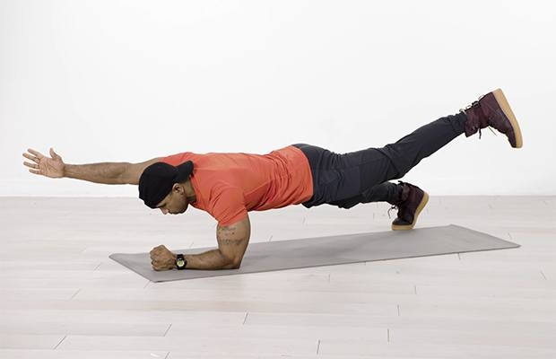
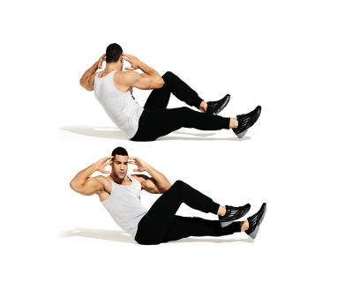
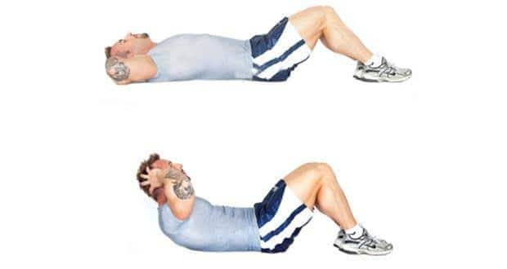
Crunches Cycles Plank Side plank Superman’s
Lower strength
Squats lunges wall sits step ups
