The different uses of stones and rocks.
- 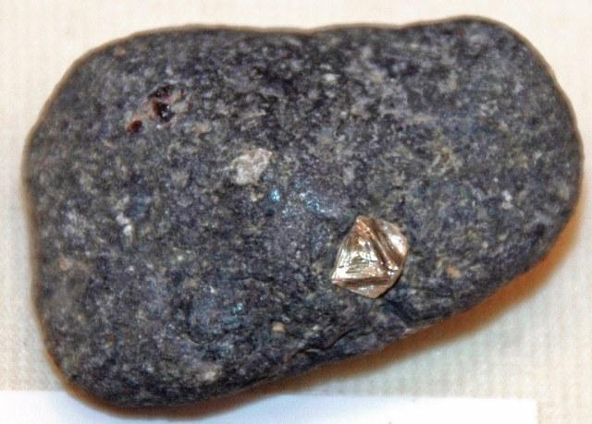
Kimberlite
This is an igneous rock. A rock made from cooled lava. These rocks sometimes contain
diamonds, which can be used for jewelry .

Coal
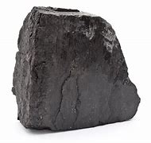
Coal is a sedimentary rock. A rock made from minerals. Coal can be set on fire, this is known as being combustible. Coal can be used to heat our homes, and to heat water in steam trains.

Marble
- 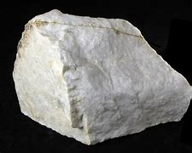

Marble is a metamorphic rock. These rocks are made when a rock is changed by its surroundings, this can be from chemicals or from pressure. Marble can be used to make bathroom tiles, kitchen tops and statues.

