Barrington C of E Primary School
Yellow Class Year 2 LTP 2022-23
 | Autumn  You are a Star! |  | Spring  Why is the Ocean Blue? |  | Summer  Fire! Fire!
English | 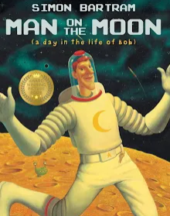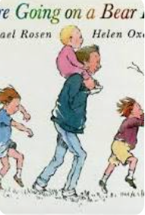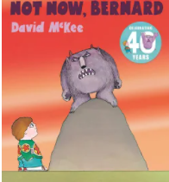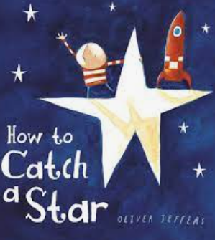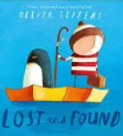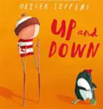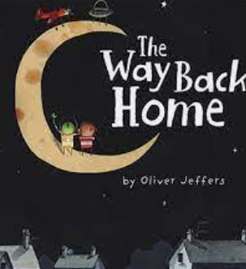Stories with recurring language; - - Write simple sentences using recurring language, words and phrases taken from familiar stories.  Poems to read aloud, perform familiar poems and write own  Non-fiction;  Labels, explanations captions and lists  Report writing based on historical event – moon landings  Guy Fawks  Nativity traditional playscripts |  | Stories with predictable phrasing- (Same author )  Non-fiction;  Non-chronological report (using technology to organise, restore & retrieve digital content.)  Stories with predictable phrasing (different cultures) |  | Traditional tales – fairy tales (Kings, Queens & Castles  Shape poems, playing with language, calligrams  Non-fiction;- Report  Grammar revision  Great Fire of London - Diary recount – Samuel Pepys  Drama – Role play the events of the Great Fire of London  Local Barrington History and compare with London.  Poems by same poet – Michael Rosen
Maths | Year 2  Number and Place Value  Addition and subtraction  Properties of shape, 2D & 3D  Money applied to the above areas  Problem solving |  | Year 2  Multiplication and division  Fractions  Measure (capacity, length, height, weight, volume, mass & time)  Problem solving |  | Year 2  Statistics  Problem solving  Gap filling, Consolidation
Science | Seasonal Changes Summer to Autumn to Winter  Harvest – plant growth & trees changing  Uses of every day materials;  - Identify and compare the suitability of a variety of everyday materials, including wood, metal, plastic, glass, brick, rock, paper, and cardboard for particular uses.  - Find out how the shapes of solid objects made from some materials can be changed by squashing, bending, twisting, and stretching.  Living things and their habitats  - Explore and compare the differences between things that are living, dead and things that have never been alive. (Autumn and hibernating)  - Identify that most living things live in habitats to which they are suited and describe how different habitats provide for the basic needs of different kinds of animals and plants, and how they depend on each other (describe and compare them) link to English non-fiction and Rainforests |  | Seasonal Changes Winter to Spring & Hibernation  Living things and their habitats  - Identify and name a variety of plants and animals in their habitats, including micro-habitats.  Link to habitats for plants at sea. &  Living, dead or never alive.  Animals including humans  - Identify and name a variety of common animals including fish, amphibians, reptiles, birds and mammals |  | Seasonal Changes Winter to Spring to Summer – tree change and plant growth  Uses of every day materials; - refer back to what we learnt in Autumn for houses that burn/do not burn easily  Living things and their habitats  - Describe how animals obtain their food from plants and other animals, using the idea of a simple food chain, and identify and name different sources of food.  - Identify that most living things live in habitats to which they are suited and describe how different habitats provide for the basic needs of different kinds of animals and plants,  - Identify that most living things live in habitats to which they are suited and describe how different habitats provide for the basic needs of different kinds of plants, and how they depend on each other (describe and compare them) link to English non-fiction and Rainforests  Animals including humans  - Find out about and describe the basic needs of animals, including humans, for survival (water, food and air)  - Describe the importance for humans of exercise, eating the right amounts of different types of food, and hygiene.
RE | Understanding Christianity: Who made the world? | Celebrations: Why is Christmas important to Christians? | Judaism - Torah  Why is the Torah such a joy for the Jewish community? | Christianity Resurrection / joy  What are the best symbols of Jesus’ death & resurrection at Easter? | Christianity - What is the good news that Jesus brings? Who was Jesus – a great leader and teacher? | Judaism–Prayer & Worship. Why do Jewish families say so many prayers and blessings?
Computing | E-safety -communicate safely  Identify where you can go for help-link with PSHE  Recognise common uses of information technology beyond school– link with systems and networks, IT all around us.  Understand what algorithms are; how they are implemented as programs on digital devices; and that programs execute by following precise and unambiguous instructions – recap scratch junior Y1  Use Chrome books to;  - Research animals and habitats  - Type questions/labels/captions etc. for a report |  | Creating Media – digital photography. & music  Data information – creating pictograms  Keeping safe (World safer internet day)  Use technology purposefully to create, organise, store, manipulate and retrieve digital content  Cross curricular/History – Tim Berners-Lee (invents WWW) |  | E-safety - Keeping Safe  Create and debug simple programs•  Use logical reasoning to predict the behaviour of simple programs  - Programming robot algorithms  - Programming - an introduction to quizzes
Geography | United Kingdom and the location of hot and cold areas of the world in relation to the Equator, North and South Poles, including Africa. Rainforests |  | Name and locate the world’s seven continents and five oceans using atlases and globes.  Understand geographical similarities and differences through studying the human and physical geography of a small area of the United Kingdom |  | Use basic geographical language and World maps, atlases & globes. - use google maps to look at physical and human features areas of UK - compare fires in Australia with Great fire of London  Simple compass and locational & directional language to describe the location of features and routes on a map (maths cross curricular).
History | Events beyond living memory that are significant nationally or globally:  David Livingstone, Christopher Columbus & Neil Armstrong  Space explorers- Make comparisons between Space explorers then and now – using archive material.  Black History Month (October)  Florence Nightingale,  Guy Fawkes |  | Events beyond living memory that are significant nationally or globally:  Grace Darling –  Link to Geography –location of lighthouses  Link to DT making a lighthouse  Events beyond living memory that are significant nationally or globally:  Titanic - Link to science and DT – boats and materials |  | Significant Individuals: - Queen Elizabeth 2nd– compare with Victoria – (2nd longest reign.)  Significant events beyond living memory: Learning about the Great Fire of London.  Changes within a location: Looking at famous landmarks of London (link with geography) and how they were built and have changed overtime and compare buildings in London and Barrington (any buildings as old as 1666?)
Art | Famous Artist  Vincent VG – Starry Night  Seasonal changes - Observational drawings of natural objects, animals, trees, flowers.  Camouflage – reptile camouflage - use of pastels & collage  Fireworks – different mediums  Christmas cards and decoration |  | Representing the Sea in different formats  Sculpture – clay fish  Easter & Mother’s day cards – |  | Seasonal changes - paint  Father’s Day Card  Fire art
DT | Make Rainforest Diaramas  Sewing – make Christmas tree using felt and stiches  Christmas cards and decorations-different techniques |  | Valentine Cards - sliders  Boats and oceans/seas - link with sinking of the Titanic & materials |  | Making a house – link with materials and GFoL  Carriages
Music | Exploring pulse and rhythm | Singing and performing (Nativity play) | Create Rhythm using un-tuned percussion  Soundscapes linked to ocean and seas, sea shanties |  | Melodies & Shape | Class composition
PE | PE taught by PE specialist  Yoga sessions with Mrs Alderton |  | PE taught by PE specialist  Yoga sessions with Mrs Alderton |  | PE taught by PE specialist  Yoga sessions with Mrs Alderton
PSHE | MMR 4 – Beginning & Belonging | Citizenship3 Working Together  Anti-bullying week | MMR6 Family & Friends | Citizenship 4 Diversity & Communities | HSL6 & 10 Relationships & Sex education  HSL 9 Personal Safety | MMR8 Managing Change

