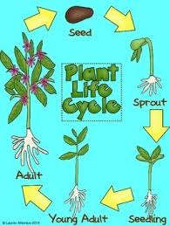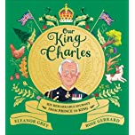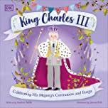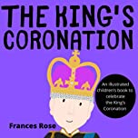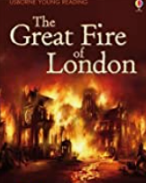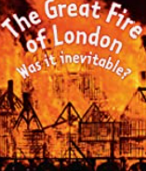
28th April 2023
Yellow Class Curriculum – Summer 2023
Dear Parents,
Welcome back to a wonderful and exciting new term. Hopefully everyone is feeling full of chocolate but well-rested. We are hoping to go on a KS1/EYFS school trip at the end of this half term which will be related to what the children have been learning – details to follow very soon!
Here are some details for you about Yellow class this term. These details will also be on the Yellow class page of the school website.
Topic: This term’s topic is split into 2 parts; the first half term we will be covering the King’s historic Coronation. In the second half term, the topic will be “Fire! Fire!” so using the Great Fire of London Museum portal to support our learning, linking Samuel Pepys diary with the history and geography of the time and area.
Curriculum
English text types we will cover: Traditional tales / fairy tales, poetry, a non-fiction report and grammar revision and comprehension practice.
Reading remains vitally important and thank you to those of you who consistently support your child’s reading at home; it really does support their learning. Reading is much more than reading words on a page; comprehension is essential, as well as being able to summarise and talk about aspects of the plot or characters, together with links to other stories or real life. Please hear your child read aloud often, supporting and encouraging them to record the books they have read and make a valuable comment about an aspect of the plot, or deduction of a character’s viewpoint or reaction, or an opinion about a particular event. Please try to fill in the Reading logs and use the Phoneme booklets to help your child practise all the phonemes/graphemes. Regular practice is essential for them to progress in both their reading and their writing. Phoneme booklets, reading books and reading records need be taken home and brought back to school every day.
Maths: We will continue to develop the children’s mathematical skills across the curriculum including following Year 2 objectives of the new Primary Framework for Maths 2014, which will also help as we continue to do our SATs revision. This gives greater emphasis on strategies for problem solving and comprises of nine strands:
- Number and place value
- Addition, subtraction, multiplication and division
- Number - fractions
- Geometry – properties of shapes
- Geometry – position and direction
- Measurement
http://www.over.cambs.sch.uk/website/calculation_methods
Foundation Topics:
In RE, we will be learning about Christianity; What is the good news that Jesus brings? Who was Jesus – a great leader and teacher? Also, Judaism; Prayer & Worship-Why do Jewish families say so many prayers and blessings?
In Science, we will be learning about Animals including humans-life cycles and the importance for humans of exercise, eating the right amounts of different types of food, and hygiene. Also; Plants and what they need to grow and remain healthy.
In History/Geography we will be looking at events beyond living memory that are significant nationally, especially regarding the Great Fire of London and the coronation of King Charles III.
In Computing we will continue to focus on E-safety – to communicate safely when on-line. In addition, we will be focusing on programming using Scratch Junior as well as Raspberry Pi, continuing using chromebooks/ ipads to research and write. As we live in a digital age, here are some useful websites for your child find out about our topics.
https://www.bbc.co.uk/bitesize/topics/zkrkscw
https://www.bbc.co.uk/bitesize/articles/z8g7tcw
https://planbee.com/blogs/news/king-charles-iii-facts
https://www.london-fire.gov.uk/museum/history-and-stories/the-great-fire-of-london/
https://www.bbc.co.uk/teach/class-clips-video/history-ks1-the-great-fire-of-london-home/zph4g7h
https://www.bbc.co.uk/bitesize/topics/zdyhn9q/articles/z4msn9q

Please monitor your child’s activity on the internet and be vigilant to ensure your child uses their knowledge of e-safety to stay safe. https://esafetytraining.org/resources/childrens-area/5-7-year-olds/ website also has links to other sites that teaches more about on-line safety.
PE: Mr Herd will teach PE on Monday and Thursdays. We have a ‘no tape’ policy for earrings so can you please ensure they are removed. Also, make sure that your child has a named PE kit in school including tracksuit bottoms, top and a change of footwear for PE as well as indoor shorts and T-shirt (especially as most lessons are outside). Occasionally, due to weather or restrictions on use of the hall we have to change days so your child’s PE kit needs to be in school at all times, especially if your child takes kit home following out of school clubs.
More information can be found on our school website, and we hope to share work from our class there too.
Thank you again for your support and we look forward to working closely and co-operatively with yourselves to maximise your child’s school experience.

Yours sincerely,
Mrs Beswick, Mrs Kershaw & Mrs Burge
YBeswick@barrington.cambs.sch.uk
lkershaw@barrington.cambs.sch.uk

